Exp 13: Create a Virtual Machine with 1 CPU, 2GB RAM and 15GB storage disk using a Type 2 Virtualization Software using Vmware workstation.

Aim
To create and configure a Virtual Machine with 1 CPU, 2 GB RAM, and a 15 GB storage disk using Type-2 virtualization software (VMware Workstation).
Procedure
- Install VMware Workstation on the host computer and open the application.
- Click Create a New Virtual Machine → Typical setup.
- Select the installation source (ISO file or OS installation later).
- Choose the Guest Operating System type (Windows/Linux) and version.
- Allocate Hardware resources:
  - Processor (CPU): 1
  - Memory (RAM): 2 GB (2048 MB)
  - Hard Disk: 15 GB virtual disk (single file or split option).
- Complete the wizard, Power On the VM, and proceed with the OS installation.
Output
Figure 1 Virtual Machine with 1 CPU, 2 GB RAM, and 15 GB storage
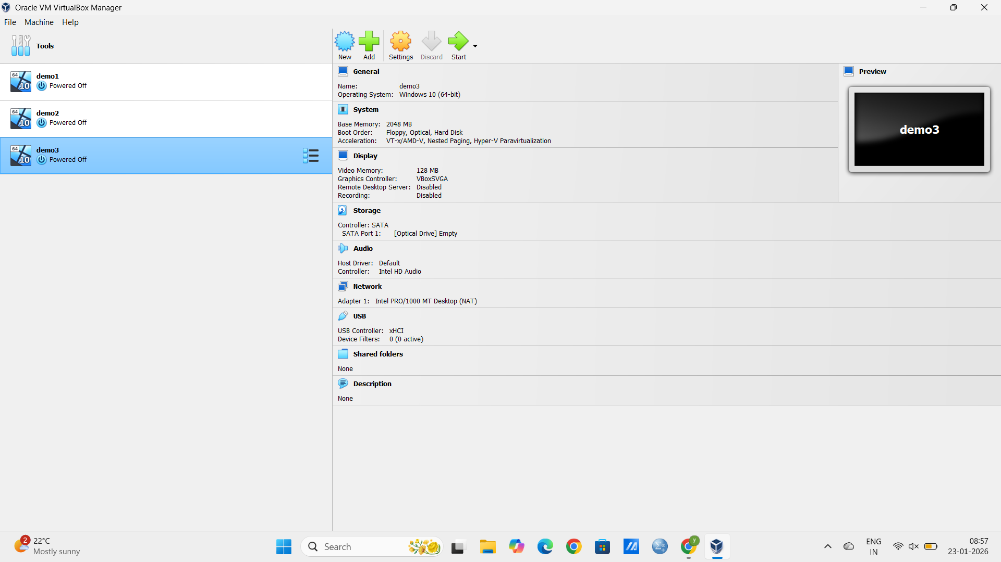 Result
A Virtual Machine with 1 CPU, 2 GB RAM, and 15 GB disk space is successfully created and configured in VMware Workstation, ready to run the selected operating system.

